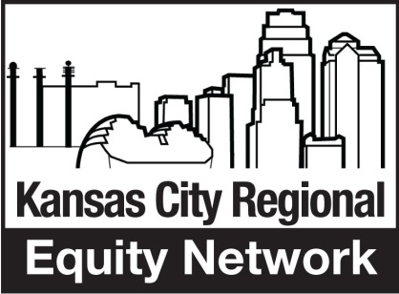
Transportation Equity Summit
April 25, 2015
DRAFT Agenda
8:00 – 8:30 Registration and continental breakfast
8:30 – 8:40 Welcome and introduction, including agenda for summit (Equity Network Co-
Chairs: Gloria Ortiz Fisher, Westside Housing & Lora McDonald, MORE²)
8:40 – 9:10 Opening remarks – the national transportation challenge (Cedric Lawson, Transportation Equity Caucus & Melissa Wells, PolicyLink
9:10 – 9:30 Keynote (Joe Reardon, Exec Director of KCATA) [Vision for regional transit and how we can help make that happen.]
9:30 – 9:50 Local transportation equity challenges (Remarks by Equity Network member
and Ron Achelpohl) [cover issues from last summit and opportunity from MARC
Transportation Planning]
9:50 – 9:55 Explain breakout sessions – purpose and logistics (Equity Network member)
9:55 – 10:05 Break and move to breakouts
10:05 – 11:00 Breakouts
Engaging in a national transportation equity strategy (PolicyLink, Laura Barett, Equity Network member) [Discuss national transportation equity strategy and how KC region can become a part of this. What 3 specific actions can we take this year?]
Impacting the KC Region’s transportation plan through MARC (Ron Achelpohl, Equity Network member) [What needs to be included in MARC Long-range Transportation Plan to help advance transportation equity in the region? What are 3 immediate steps for the Equity Network to take?]
Equity Network short-term transportation equity strategy (Equity Network members) [The Equity Network strategy could include three elements: 1) support of national transportation equity strategy, 2) engagement with development and implementation of MARC Long-range Transportation Plan, and 3) a regional transportation equity strategy. Focus of this third breakout is what can the equity network do to promote transportation equity in the region? What are three specific actions that can be taken?]
11:00 – 11:05 Return to main session
11:05 – 11:45 Report from breakout sessions and discussion about proposed agenda. (Equity Network members) [Each breakout presents specific actions that Equity Network
members and citizens in general can take in 2015 to advance transportation equity in the nation and region. Should probably limit each breakout to 3 specific actions we can take. Group discussion if this seems like an impactful transportation equity agenda for the Equity Network to champion?]
11:45-12:00 Wrap-Up (Equity Network Co-chairs) [Reinforce actions that came out of breakout sessions and Equity Network’s commitment to pursue them. Call for folks to get involved in this work (maybe we need commitment cards on each table). Thank everyone.]

